Paul Milando, voice actor, shares invaluable career advice and unveils his experience in the industry
Many feel anxious thinking about whether it is a good decision to work on pursuing their passion as a career. Paul Milando, a 56-year-old voice actor living in Hamilton, Ontario, proves that it is possible to create a successful career out of your passion if you are dedicated to your craft.
Voice actor Milando is a graduate of the Bachelor of Arts in English program at Trent University. As a university student, he was a part of radio shows. His friends suggested that he should pursue his passion for drama, theater and voice acting as a career after graduation.
Milando followed his friends’ advice and began giving auditions in the mid 90s. For six years, Milando worked for Vox Talent INC. Milando eventually decided to change the agency he works with to access better opportunities. He now works with Ta-Da Voiceworks.
He stated, “I would get a lot of the same kind of auditions, and they were not really challenging. This is why I sort of left. It was really hard to sit down and decide that you’re going to leave, but I got too comfortable. I wanted to challenge myself”.
When speaking to students, Milando emphasized on the importance of attaining formal training and investing in your craft. He mentioned, “Even though I’ve done voiceover for a while, I still take classes”.
To improve his skills as a voice actor, Milando participated in workshops hosted by Second City Training Centre in Toronto, Canada. The workshop required attendees to audition, and Milando mentioned that participating in the workshop significantly improved his skillset. He was working alongside many talented artists.
Apart from participating in workshops where Milando was able to improve his skills, Milando invested in an at-home studio to produce higher quality audio recordings.
At the beginning of his career, Milando researched homemade sound booths and created a dedicated recording space in his closet. Today, he has an acoustically treated sound booth at his home, where he can record without worrying about having external sounds in his recordings.
Milando mentioned that in recent times, a lot of voiceover work is being completed remotely, making it compulsory to have a dedicated recording space at home and invest in high-quality technology.
He said, “They want to make sure your voice quality is good. If you are going to be a voice over person, you have to have those tools available”.
Milando looks forward to pursing voice acting as a full-time career. At the moment, Milando works for a boat repair company full-time as a mechanic and works on voiceover projects part-time.
He stated, “For me, I work full-time. I used to call this a part-time thing, but my kids call it a hustle. I want to shift so I do more voicework. This entails more auditions and more exposure. This is all about persistence”.
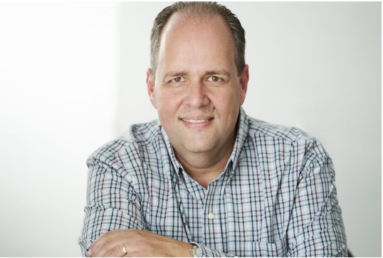
(Website: https://paulmilando.ca/gallery/ Organization: Paul Milando, 2024
This image is of Paul Milando, voice actor)
-30-
Word count - 487

